# IMPLEMENT A MAPREDUCE PROGRAM TO PROCESS A WEATHER DATASET

**AIM:**

To implement a MapReduce python program to process a weather dataset in Hadoop.

# PROCEDURE:

1. Open command prompt as administrator and start the Hadoop by using the command.

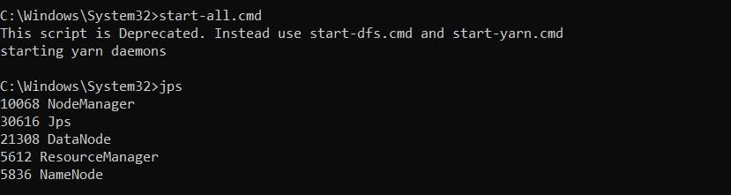

1. Create a new directory in the Hadoop file systems using the command and Upload the input text file into the weather directory using the command.





1. Create the mapper and reducer files.

# MAPPER.PY:

import sys def map1():

for line in sys.stdin:

tokens = line.strip().split() if len(tokens) < 13:

continue

station = tokens[0]

if "STN" in station: continue

date_hour = tokens[2] temp = tokens[3] dew = tokens[4] wind = tokens[12]

if temp == "9999.9" or dew == "9999.9" or wind == "999.9": continue

hour = int(date_hour.split("_")[-1])

date = date_hour[:date_hour.rfind("_")-2] if 4 < hour <= 10:

section = "section1" elif 10 < hour <= 16:

section = "section2" elif 16 < hour <= 22:

section = "section3" else:

section = "section4"

key_out = f"{station}_{date}_{section}" value_out = f"{temp} {dew} {wind}" print(f"{key_out}\t{value_out}")

if name == " main ": map1()

# REDUCER.PY:

import sys def reduce1():

current_key = None

sum_temp, sum_dew, sum_wind = 0, 0, 0

count = 0

for line in sys.stdin:

key, value = line.strip().split("\t")

temp, dew, wind = map(float, value.split()) if current_key is None:

current_key = key if key == current_key:

sum_temp += temp sum_dew += dew sum_wind += wind count += 1

else:

avg_temp = sum_temp / count avg_dew = sum_dew / count avg_wind = sum_wind / count

print(f"{current_key}\t{avg_temp} {avg_dew} {avg_wind}") current_key = key

sum_temp, sum_dew, sum_wind = temp, dew, wind count = 1

if current_key is not None: avg_temp = sum_temp / count avg_dew = sum_dew / count avg_wind = sum_wind / count

print(f"{current_key}\t{avg_temp} {avg_dew} {avg_wind}") if name == " main ":

reduce1()

1. To execute the files with Hadoop streaming run the following command.

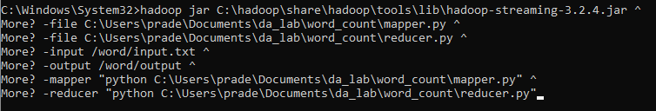

# OUTPUT:

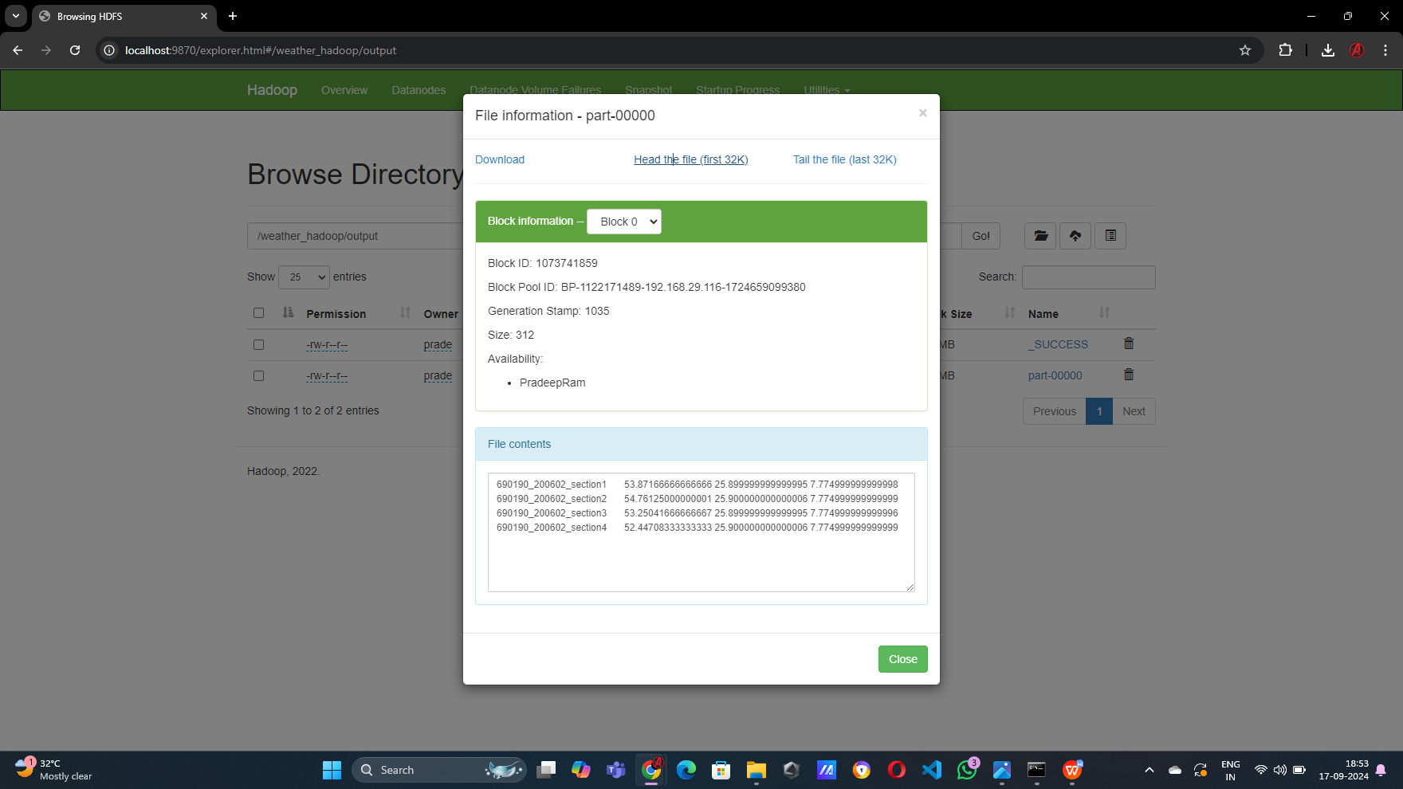

**RESULT:**

Thus the implementation of the MapReduce python program to process a weather dataset in Hadoop is executed successfully.